FOOD SPOILAGE WASTE ONLY

Food that is damaged
or out of date

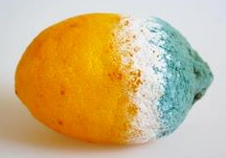

FOOD PREPARATION WASTE ONLY

Food waste from preparation
e.g. offcuts and peelings
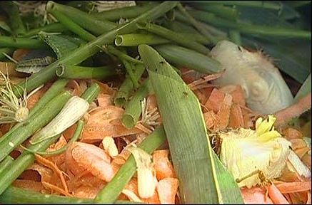

PLATE WASTE ONLY

Food left on
customers’ plates
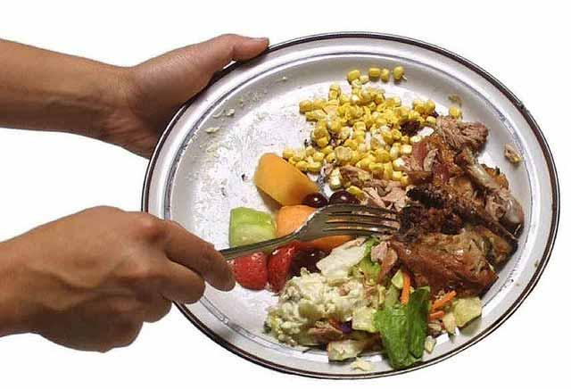

[INSERT FOOD WASTE TYPE] ONLY

[Details on food waste type]

[Insert picture]

